**Project Title: Project Design Phase-I** - **Solution Fit Template Team ID:** PNT2022TMIDxxxxxx

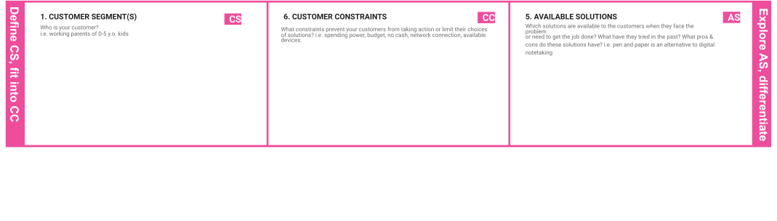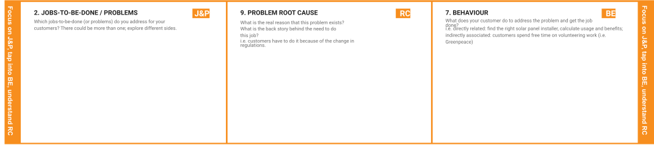

Smart waste management in metropolitan cities

PNT2022TMID17711

~Bad smell spreads and may cause illness to local people.

~A reduction waste collection cost, trash and don't have to be emptied useless they reach certain levels enables city planners to optimize collection roots saving fuel time and money.

~Municipality

~Hospital

~Metropolitan city citizens

~The garbage collecting vehicle to collect the waste in twice and thrice in a week.

~Requires recycling and protection against chemical substance.

~More frequent food waste collection.

~Recycling the wastes.

~You will create and the plans in place to provide a reliable and efficient service for collection,transportation and disposal of waste.

~The overflowing needs to be avoided.

~The garbage cans must cleaned after it got filled.

~Customer is expected to pay a critical and difficult to predict role in both generation and proper disposal of waste.

~The sensors senses the amount of wastes in the trashcans.

~Lack of public awareness. ~Refusal to learn about compliance.

~Insuffficient investment in waste management.

~Poor waste management system.

|  |  |  |  |  |
| --- | --- | --- | --- | --- |
|  | **3. TRIGGERS TR**  What triggers customers to act? i.e. seeing their neighbour installing solar panels, reading about a more efﬁcient solution in the news. | **10. YOUR SOLUTION SL**  If you are working on an existing business, write down your current solution ﬁrst, ﬁll in the canvas, and check how much it ﬁts reality.  If you are working on a new business proposition, then keep it blank until you ﬁll in the canvas and come up with a solution that ﬁts within customer limitations, solves a problem and matches customer behaviour. | 1. **CHANNELS of BEHAVIOUR CH**    1. **ONLINE**   What kind of actions do customers take online? Extract online channels from #7   * 1. **OFFLINE**   What kind of actions do customers take ofﬂine? Extract ofﬂine channels from #7 and use them for customer development.  ~Weekly thrice go and collect the garbage. |  |
| **4. EMOTIONS: BEFORE / AFTER EM**  How do customers feel when they face a problem or a job and afterwards?  i.e. lost, insecure > conﬁdent, in control - use it in your communication strategy & design.  ~They feel tough and then feel concerned. |